**Q. define data warehouse**

A data warehouse is **a large collection of business data used to help an organization make decisions**.

A data warehouse is a large, centralized repository of structured data that is designed to support business intelligence activities, such as data analysis and reporting.

The primary goal of a data warehouse is to provide a unified view of an organization's data that can be used to support decision-making and strategy formation.

**Q. what is a ETL Tool**

ETL stands for Extract, Transform, Load, and refers to a process in data warehousing that involves extracting data from a variety of sources, transforming it into a format that can be loaded into a target database for analysis and reporting purposes.

An ETL tool is software that automates this process and makes it more efficient. ETL tools typically provide a visual interface that allows users to define the data extraction, transformation, and loading rules and processes, making it easier to manage the flow of data between different systems. The tool can handle a wide range of data formats, including structured data, semi-structured data, and unstructured data.

Some popular ETL tools include Apache NiFi, Talend, Informatica PowerCenter, and Microsoft SQL Server Integration Services (SSIS). These tools are widely used in industries such as finance, healthcare, retail, and e-commerce, among others, to manage large amounts of data and ensure its accuracy and completeness for business intelligence and reporting purposes.

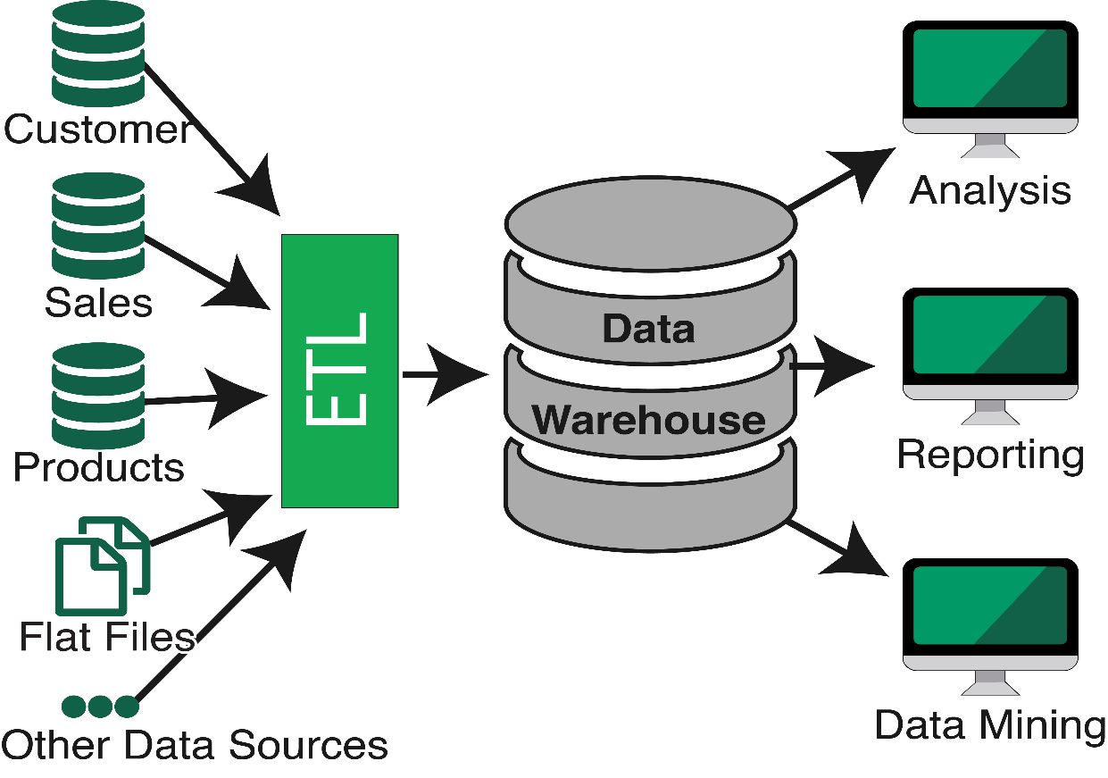

**Linux Commands**

important Linux commands that are frequently used in Abinitio with examples:

1. ls: Used to list the files and directories in a directory. Example: "ls /home/user" will list all the files and directories in the "/home/user" directory.
2. cd: Used to change the current working directory. Example: "cd /home/user" will change the current working directory to "/home/user".
3. pwd: Used to print the current working directory. Example: "pwd" will display the absolute path of the current working directory.
4. cp: Used to copy files and directories. Example: "cp file.txt /home/user/backup" will copy the file "file.txt" to the "/home/user/backup" directory.
5. mv: Used to move or rename files and directories. Example: "mv file.txt /home/user/backup" will move the file "file.txt" to the "/home/user/backup" directory.
6. rm: Used to delete files and directories. Example: "rm file.txt" will delete the file "file.txt".
7. mkdir: Used to create a new directory. Example: "mkdir /home/user/new_dir" will create a new directory called "new_dir" in the "/home/user" directory.
8. rmdir: Used to remove an empty directory. Example: "rmdir /home/user/empty_dir" will remove the directory "empty_dir" if it is empty.
9. cat: Used to display the contents of a file. Example: "cat file.txt" will display the contents of the file "file.txt".
10. less: Used to view the contents of a file page by page. Example: "less file.txt" will display the contents of the file "file.txt" page by page.
11. head: Used to display the first few lines of a file. Example: "head -n 5 file.txt" will display the first 5 lines of the file "file.txt".
12. tail: Used to display the last few lines of a file. Example: "tail -n 5 file.txt" will display the last 5 lines of the file "file.txt".
13. grep: Used to search for a pattern in a file. Example: "grep 'error' file.txt" will display all the lines in the file "file.txt" that contain the word "error".
14. find: Used to search for files and directories. Example: "find /home/user -name '*.txt'" will search for all ".txt" files in the "/home/user" directory and its subdirectories.
15. chmod: Used to change the permissions of files and directories. Example: "chmod 755 file.txt" will give the owner full permissions, and all others read and execute permissions for the file "file.txt".

**PWD Command: -**

PWD stands for Print Working Directory

This command is used to show the current working directory. For example /home/foobar

**ls Command: -**

ls a will list all files including hidden files (files with names beginning with a dot).

**ls –ltr (ls -lrt) Command:-**

This command will list you all files according to the order of time in which they were created. Here “ltr” stands for l- long listing, t- time, r- recursive. The list displayed contains a file name, file permissions, owner of the file, group, date and time of file creation and links.

**ls -lart Command: -**

this Command is used to display hidden file or directories.

**ls command: -**

The ls command is one of the most commonly used commands in daily Linux/UNIX operations.

**ls -l Command: -**

The "ls -l" option **displays the contents of the current directory in a long listing format, one per line**. The line begin with the file or directory permission, owner and group name, file size, created/modified date and time, file/folder name as some of the attributes.

**mkdir command**

mkdir command in Linux **allows the user to create Multiple directories** .

Just **type "mkdir <dir name> , in place of <dir name> type the name of new directory, you want to create and then press enter**. Example: mkdir created.

by using. (dot) you can create hidden directories. For example:- mkdir .abdc

**touch command**

touch filename. We can use the touch command to create new files by giving file names as the input. We can create multiple files Example:- touch a.dat b.dat c.txt

by using. (dot) you can create hidden files. For Example:- touch .abdc

**cat Command**

Using the cat command, you can quickly create a file and put text into it. To do that, use the **>** redirect operator to redirect the text in the file.

cat > filename.txt

The file is created, and you can begin populating it with text. To add multiple lines of text just press **Enter** at the end of each line.  Once you’re done, hit **CTRL+D** to exit the file.

**Cp command**

'cp' means copy. 'cp' command is used to copy a file or a directory.

copy a file into the same directory syntax

**cp <existing file name> <new file name>**

**cat command**

The 'cat' command can be used to display the content of a file.

Syntax:

cat <fileName>

|  |  |
| --- | --- |
| **Option** | **Function** |
| [cat > [fileName]](https://www.javatpoint.com/linux-cat#linux-cat-create) | To create a file. |
| [cat [oldfile] > [newfile]](https://www.javatpoint.com/linux-cat#linux-cat-copy) | To copy content from older to new file. |
| [cat [file1 file2 and so on] > [new file name]](https://www.javatpoint.com/linux-cat#linux-cat-concatenate) | To concatenate contents of multiple files into one. |
| [cat -n/cat -b [fileName]](https://www.javatpoint.com/linux-cat#linux-cat-display-line-numbers) | To display line numbers. |
| [cat -e [fileName]](https://www.javatpoint.com/linux-cat#linux-cat-e) | To display $ character at the end of each line. |
| [cat [fileName] <<EOF](https://www.javatpoint.com/linux-cat#linux-cat-end-marker) | Used as page end marker. |

**wc Command**

Linux wc command helps in counting the lines, words, and characters in a file. It displays the number of lines, number of characters, and the number of words in a file. Mostly, it is used with pipes for counting operation.

Syntax:

**wc [OPTION]... [FILE]...**

**wc [OPTION]... --files0-from=F**

**rm Command**

The Delete File 'rm' means remove. This command is used to remove a file. The command line doesn't have a recycle bin or trash unlike other GUI's to recover the files. Hence, be very much careful while using this command. Once you have deleted a file, it is removed permanently.

Syntax:

rm <filename>

Example:

rm myfile1

**head Command**

The 'head' command displays the starting content of a file. By default, it displays starting 10 lines of any file.

Syntax:

head <file name>

Example:

head jtp.txt

**tail Command**

Linux tail command is used to display the last ten lines of one or more files. Its main purpose is to read the error message. By default, it displays the last ten lines of a file. Additionally, it is used to monitor the file changes in real-time. It is a complementary command of the head command.

**Syntax:**

tail <file name>

**other Commands: -**

cd

cd-

pwd

echo $home

df – kh

ls lrt d*

listout the all linux commands are used in a abinitio

1. **cd:** This command is used to **change the current directory.** For example, "cd /home/user/" will change the current directory to the user's home directory.
2. **ls:** This command is used to **list the files** in the current directory. For example, "ls -l" will list the files in the current directory in a long format.
3. **chmod:** This command is used to **change the permissions of a file or directory**. For example, "chmod 755 file.txt" will give read, write, and execute permissions to the owner of the file and read and execute permissions to all other users.
4. **rm:** This command is used to **remove a file or directory**. For example, "rm file.txt" will remove the file named "file.txt".
5. **mkdir:** This command is used to **create a new directory**. For example, "mkdir mydirectory" will create a new directory named "mydirectory".
6. **rmdir**: This command is used **to remove a directory**. For example, "rmdir mydirectory" will remove the directory named "mydirectory".
7. **tar**: This command is used **to create, manipulate, and extract files from a tar archive**. For example, "tar -cvf archive.tar file1 file2" will create a new tar archive containing files "file1" and "file2".
8. **scp**: This command is **used to securely copy files between hosts**. For example, "scp file.txt [user@remote.host](mailto:user@remote.host):/remote/directory/" will copy the file "file.txt" to the remote host at directory "/remote/directory/".
9. **ssh**: This command is used to connect to a remote host over a secure shell. For example, "ssh [user@remote.host](mailto:user@remote.host)" will establish a secure shell connection to the remote host as the user "user".
10. **cat**: This command is **used to display the contents of a file**. For example, "cat file.txt" will display the contents of the file "file.txt" on the console.
11. **tail**: This command is used to **display the last few lines of a file**. For example, "tail -n 10 file.txt" will display the last 10 lines of the file "file.txt".
12. **head**: This command is used to **display the first few lines of a file**. For example, "head -n 5 file.txt" will display the first 5 lines of the file "file.txt".
13. **grep**: This command **is used to search for a pattern** in a file. For example, "grep 'pattern' file.txt" will search for the pattern "pattern" in the file "file.txt".
14. **ps**: This command is used to **display the currently running processes.** For example, "ps aux" will display all the running processes along with their details.
15. **kill**: This command is **used to terminate a running process**. For example, "kill -9 PID" will terminate the process with the process ID "PID".
16. **top**: This command is used to **display the system resource usage and the currently running processes in real-time**. For example, running "top" will display the resource usage of the system and the processes that are currently running.
17. **ifconfig**: This command is used to display the network interface configuration. For example, "ifconfig eth0" will display the configuration details of the network interface "eth0".
18. **netstat**: This command is used to display the network connections and their status. For example, "netstat -an" will display all the active network connections and their status.
19. **df**: This command is used to **display the disk space usage**. For example, "df -h" will display the disk space usage in a human-readable format.
20. **du**: This command is used to **display the disk usage of a file or directory**. For example, "du -sh /path/to/directory" will display the disk usage of the directory in a human-readable format.
21. **find**: This command is used to search for files and directories based on various criteria. For example, "find /path/to/search -name 'filename'" will search for the file named "filename" in the directory "/path/to/search" and its subdirectories.
22. **tar**: This command is also used to **extract files from a tar archive**. For example, "tar -xvf archive.tar" will extract the files from the tar archive "archive.tar".
23. **ping**: This command is **used to test the connectivity to a network host**. For example, "ping google.com" will test the connectivity to the website "google.com".
24. **ifup/ifdown:** These commands are used to bring up or take down a network interface. For example, "ifup eth0" will bring up the network interface "eth0".
25. **uname:** This command is used to **display the system information**. For example, "uname -
26. **echo**: This command is used to **display text on the console or to redirect text to a file**. For example, "echo 'Hello, World!'" will display the text "Hello, World!" on the console.
27. **wc**: This command is **used to count the number of lines,** words, and characters in a file. For example, "wc -l file.txt" will count the number of lines in the file "file.txt".
28. **sort**: This command is **used to sort the contents of a file**. For example, "sort file.txt" will sort the lines in the file "file.txt" in ascending order.
29. **uniq**: This command is **used to remove duplicate lines from a file.** For example, "uniq file.txt" will remove the duplicate lines in the file "file.txt".
30. **diff**: This command is used to compare the contents of two files. For example, "diff file1.txt file2.txt" will **display the differences between the files** "file1.txt" and "file2.txt".
31. **tar**: This command can also be **used to create a compressed archive of files**. For example, "tar -czvf archive.tar.gz file1 file2" will create a compressed tar archive "archive.tar.gz" containing files "file1" and "file2".
32. **chown**: This command is used to **change the owner of a file or directory**. For example, "chown user:group file.txt" will change the owner of the file "file.txt" to the user "user" and the group "group".
33. **top**: This command can be used to monitor the system resource usage and the currently running processes in real-time.
34. **chmod**: This command is **used to change the file permission modes**. For example, "chmod 755 file.txt" will give the owner of the file full permission and everyone else read and execute permission.
35. **scp**: This command is used to copy files securely between hosts over the network. For example, "scp file.txt user@hostname:/path/to/destination" will copy the file "file.txt" to the remote host "hostname" to the specified path.
36. **ssh**: This command is used to securely connect to a remote host over the network. For example, "ssh user@hostname" will connect to the remote host "hostname" as the user "user".
37. **sed**: This command is used to perform text transformations on a file or stream. For example, "sed 's/old_text/new_text/g' file.txt" will replace all occurrences of "old_text" with "new_text" in the file "file.txt".
38. **awk**: This command is used to process and manipulate text data. For example, "awk '{print $1,$3}' file.txt" will print the first and third fields of each line in the file "file.txt".
39. **crontab**: This command is used to schedule tasks to run at specific times. For example, "crontab -e" will open the crontab editor where you can schedule tasks to run at specific intervals.
40. **history**: This command **is used to display the command history of the current session.** For example, "history | tail -n 10" will display the last 10 commands that were executed in the current session.
41. **cut**: This command **is used to extract specific columns from a file.** For example, "cut -d',' -f1,3 file.csv" will extract the first and third columns of the comma-separated file "file.csv".
42. **grep**: This command is **used to search for patterns in a file**. For example, "grep 'pattern' file.txt" will search for the pattern "pattern" in the file "file.txt".
43. **diff**: This command is **used to compare two files line by line.** For example, "diff file1.txt file2.txt" will display the differences between the files "file1.txt" and "file2.txt".
44. **kill**: This command is used to terminate a running process. For example, "kill PID" will terminate the process with the specified PID.
45. **ps**: This command is used to display the currently running processes. For example, "ps -ef" will display all the currently running processes.
46. **netstat**: This command is used to display network connections and statistics. For example, "netstat -an" will display all the current network connections.
47. **wget**: This command is used to download files from the internet. For example, "wget <https://example.com/file.txt>" will download the file "file.txt" from the website "example.com".
48. **curl**: This command is used to transfer data from or to a server. It can be used to download files or upload data to a server. For example, "curl -O <https://example.com/file.txt>" will download the file "file.txt" from the website "example.com".
49. **awk**: This command is used for text processing and data extraction. It can be used to extract specific columns from a file or to perform calculations on the data. For example, "awk '{print $1,$3}' file.txt" will print the first and third columns of each line in the file "file.txt".
50. **sed**: This command is used to perform text transformations on a file or stream. It can be used to find and replace text or to delete lines from a file. For example, "sed 's/old_text/new_text/g' file.txt" will replace all occurrences of "old_text" with "new_text" in the file "file.txt".
51. **tee**: This command is used to redirect output to a file and also to the console. For example, "ls | tee file.txt" will list the files in the current directory and also redirect the output to the file "file.txt".
52. **tailf**: This command is used to display the last few lines of a file and also to follow the file as it grows. For example, "tailf file.txt" will display the last few lines of the file "file.txt" and also keep following the file as new data is added to it.
53. **ping**: This command is used to test the connectivity to a remote host by sending packets to the host and measuring the response time. For example, "ping google.com" will test the connectivity to the website "google.com".
54. **du**: This command is used to display the disk usage of files and directories. For example, "du -sh /path/to/directory" will display the total disk usage of the directory at the specified path.
55. **df**: This command is used to display the disk space usage of the file system. For example, "df -h" will display the disk space usage in a human-readable format.